**CA2 – Project 2-1,2-2, 2-3**

Case Project 2-1:

Instead of using a hub for your network configuration, implement Switches into your network. Switches are capable of simultaneously sending and receiving data from the clients on the network. The ports on the switch also have their own dedicated bandwidth so nothing will impede the speed of the network.

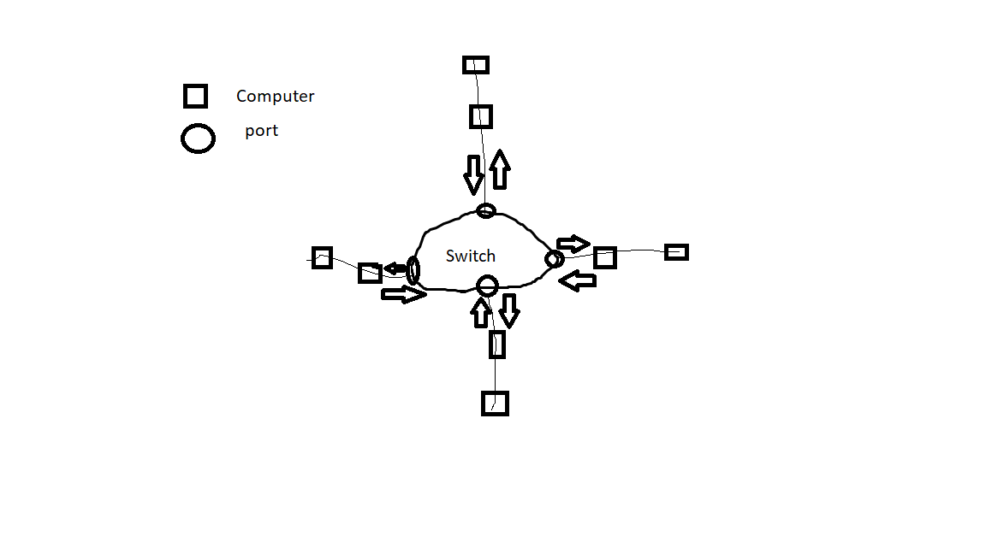

Case Project 2-2:

In this case, to reduce the number of packets, the implementation of routers will do the job. A router does not forward broadcast frames, instead it reads the destination ip addresses of the data compares it with the lists of networks in its routing table. When a match is found, the router will send the data to its destination.

Case Project 2-3:

**Physical vs. Logical topology** – Logical topology is how devices appear connected to the user, while physical topology refers to how the devices are actually connected with wires and cables.

**Bus topology** – nodes are directly connected to a common linear half-duplex link, or bus.

**Star topology** – each individual piece of a network is attached to a hub

**Ring topology** –each node in a network connects to two other nodes, creating a continuous pathway for signals through each node, a ring

**Ethernet and CSMA/CD** – CSMA/CD (Carrier Sense Multiple Access/Collision Detection) is the transmission method used in Ethernet networks.